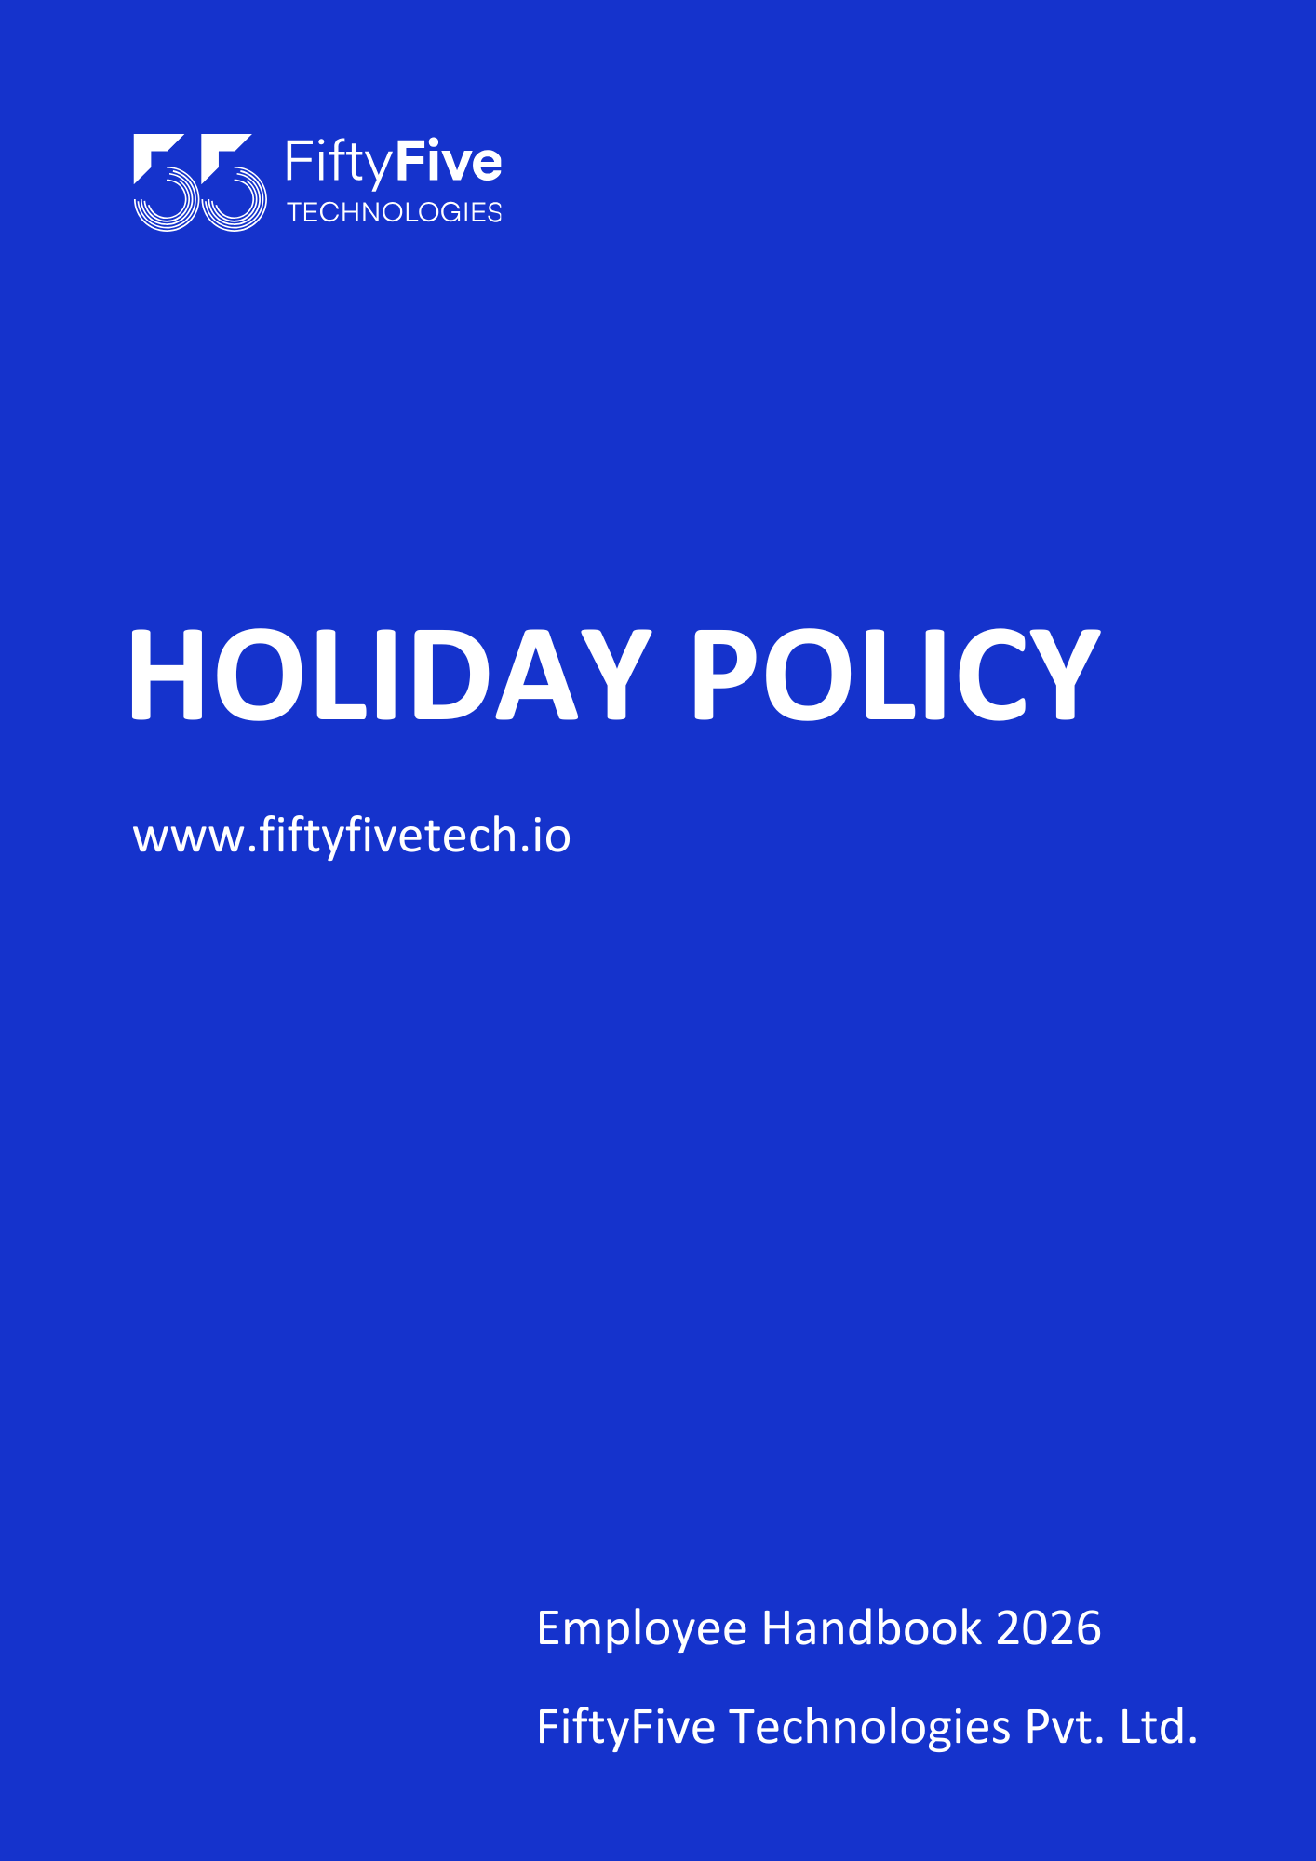

HOLIDAY POLICY

Document Release Notice

This FiftyFive Technologies Policy on holiday policy is released for use in FiftyFive Technologies Pvt Limited with effect from 01 January 2026.
This document is subject to FiftyFive Technologies Pvt Limited Procedure and subject to change any time as per the company policy.

Approved By: Jyothi Sharma (CEO-FiftyFive Technologies Pvt. Limited)
Approved By: Sanchi Saxena (Head HR-FiftyFive Technologies Pvt Limited)

Introduction
FiftyFive Technologies Pvt. Ltd. establishments observe 10 paid holidays in a calendar year. These holidays include National Statutory Holidays, Company Fixed Holidays, and Flexi (Floater) Holidays.
The holidays fall on days of national significance, key festivals, or specific occasions observed across regions or faiths. As FiftyFive Technologies operates in multiple cities with a diverse workforce from across the country, the concept of Flexi (Floater) Holidays has been introduced to provide associates the flexibility to observe regional or religious occasions not covered under the standard company holiday list.
The list of National Statutory Holidays, Company Fixed Holidays, and Flexi Holiday options is available on:
KEKA > Organization Documents > Holiday Calendar

Applicability
This policy is applicable to:
- All full-time employees, including trainees and probationers, working in India.
This policy is not applicable if in case:
- Any employee is working on-site at client location or under client directed work from home arrangement.
- In such cases the client’s official holiday calendar may apply.

Purpose
The purpose of this policy is to provide flexibility to associates to choose certain holidays for specific regional or religious observances while maintaining a uniform holiday structure across the organization.

Provisions
FiftyFive Technologies publishes a list of paid company holidays every calendar year. There are 10 holidays allotted in the year of 2026, which include:

- National Statutory Holidays
The Company observes three national statutory holidays in a calendar year. These holidays are common and uniformly applicable across all FiftyFive Technologies establishments in India.

- Company Fixed Holidays
In addition to national statutory holidays, the Company declares five fixed company holidays each year. which are uniformly observed across applicable locations.
The final list of fixed company holidays is published annually by HR on KEKA.

- Floater Holidays
- A Floater Holiday is a paid flexible holiday that may be used to observe religious, festive, or civic occasions chosen by the associate from the approved FiftyFive Technologies Floater Holiday list.
- Out of the total 10 holidays, a predefined list of flexible holidays will be designated by FiftyFive Technologies as Floater Holidays. Employees may avail up to two (2) floater leaves per calendar year, only on the specified occasions listed.
- The list of Floater Holidays is compiled by the HR Department each year and published on KEKA.
- Unused Floater Holidays cannot be carried forward to the next calendar year and will automatically lapse if not availed during the designated occasions within the same year. Floater leave may be availed for a minimum of half-day and a maximum of one full day.
- To avail a Floater Holiday, the employee must apply at least 15 days prior to the intended holiday through the KEKA portal. The request must be approved by the Reporting Manager and the HR Department.
- Floater leave is not an automated entitlement and grant of floater leave shall be subject to managerial approval and business exigencies

Holiday Calendar List for 2026
National Holidays / Fixed Leaves
Sr. No | Holiday | Month | Date | Day | Remarks
1 | New Year - 2026 | January | 1-Jan-26 | Thursday | Fixed
2 | Republic Day | January | 26-Jan-26 | Monday | Fixed
3 | Holi | March | 4-Mar-26 | Wednesday | Fixed
4 | Independence Day | August | 15-Aug-26 | Saturday | Weekend
5 | Mahatma Gandhi Jayanti | October | 2-Oct-26 | Friday | Fixed
6 | Dusshera | October | 20-Oct-26 | Tuesday | Fixed
7 | Diwali | November | 8-Nov-26 | Sunday | Weekend
8 | Christmas Day | December | 25-Dec-26 | Friday | Fixed

FLOATER LEAVES:

Sr. No | Holiday | Month | Date | Day | Remarks
1 | Makar Sankranti / Pongal | January | 14-Jan-26 | Wednesday | Floater Leave
2 | Rangpanchmi | March | 8-Mar-26 | Sunday | Weekend
3 | Eid-ul-Fitr | March | 21-Mar-26 | Saturday | Weekend
4 | Ram Navami | March | 26-Mar-26 | Thursday | Floater Leave
5 | Mahaveer Jayanti | March | 31-Mar-26 | Tuesday | Floater Leave
6 | Good Friday | April | 3-Apr-26 | Friday | Floater Leave
7 | Ambedkar Jayanti | April | 14-Apr-26 | Tuesday | Floater Leave
8 | Eid Al Adha | May | 27-May-26 | Wednesday | Floater Leave
9 | Onam | August | 26-Aug-26 | Wednesday | Floater Leave
10 | Raksha Bandhan | August | 28-Aug-26 | Friday | Floater Leave
11 | Janmashtami | September | 4-Sep-26 | Friday | Floater Leave
12 | Ganesh Chaturthi | September | 14-Sep-26 | Monday | Floater Leave
13 | Mahav Navmi / Durga Pooja | October | 19-Oct-26 | Monday | Floater Leave
14 | Bhai Dooj | November | 11-Nov-26 | Wednesday | Floater Leave
15 | Chhath Pooja | November | 15-Nov-26 | Sunday | Weekend
16 | Guru Nanak Jayanti | November | 24-Nov-26 | Tuesday | Floater Leave

Right to Amend Policies
This Employee Handbook is intended to provide general guidance on Company policies and practices. FiftyFive Technologies reserves the right to amend, modify, suspend, or withdraw any policy, procedure, or benefit described in this handbook at any time, with or without notice, based on business, operational, or legal requirements.



